PROJECT REPORT
Incident Lifecycle Automation in ServiceNow

CONTENTS
1. INTRODUCTION
1.1 Project Overview
1.2 Purpose
2. IDEATION PHASE
2.1 Problem Statement
2.2 Empathy Map Canvas
2.3 Brainstorming
3. REQUIREMENT ANALYSIS
3.1 Customer Journey map
3.2 Solution Requirement
3.3 Data Flow Diagram
3.4 Technology Stack
4. PROJECT DESIGN
4.1 Problem Solution Fit
4.2 Proposed Solution
4.3 Solution Architecture
5. PROJECT PLANNING & SCHEDULING
5.1 Project Planning
6. FUNCTIONAL AND PERFORMANCE TESTING
6.1 Performance Testing
7. RESULTS
7.1 Output Screenshots
8. ADVANTAGES & DISADVANTAGES
9. CONCLUSION
10. FUTURE SCOPE
11. APPENDIX
Source Code(if any)
Dataset Link
GitHub & Project Demo Link

1. INTRODUCTION

1.1 Project Overview
Incident Lifecycle Automation in ServiceNow is an academic project focused on standardizing and automating the Incident Management lifecycle in ServiceNow. It addresses incidents reported through email, phone, or informal communication, where inconsistent recording, classification, ownership, escalation, resolution tracking and related-record management can reduce visibility.
The defined lifecycle covers service and service offering setup, incident creation, classification, Knowledge and Agent Assist, assignment and reassignment, Level 2 investigation, emergency change activity, child incidents, resolution, Knowledge creation, SLA tracking and final validation.

1.2 Purpose
The purpose is to establish a structured and traceable Incident Management process in ServiceNow that supports consistent intake, clear ownership, knowledge-supported troubleshooting, Level 2 escalation, related change and child-incident tracking, documented resolution and SLA visibility.
Stakeholders are End Users, Service Desk Agents, Level 2 Support, Change Management Team and ServiceNow Administrator.

2. IDEATION PHASE

2.1 Problem Statement
Problem | Customer | Need | Current difficulty | Effect
PS-1 | End User | Report an IT issue and receive visible resolution | Issues may arrive through different channels and may not be consistently classified or tracked | Uncertainty about progress and resolution
PS-2 | Service Desk Agent | Create, classify, assign and resolve incidents efficiently | Classification, escalation, Knowledge, change and related incidents require coordination | Difficulty maintaining consistent ownership and tracking

2.2 Empathy Map Canvas
The Service Desk Agent is used as the primary perspective because this role performs incident creation, classification, assignment, escalation, Knowledge use and resolution documentation.
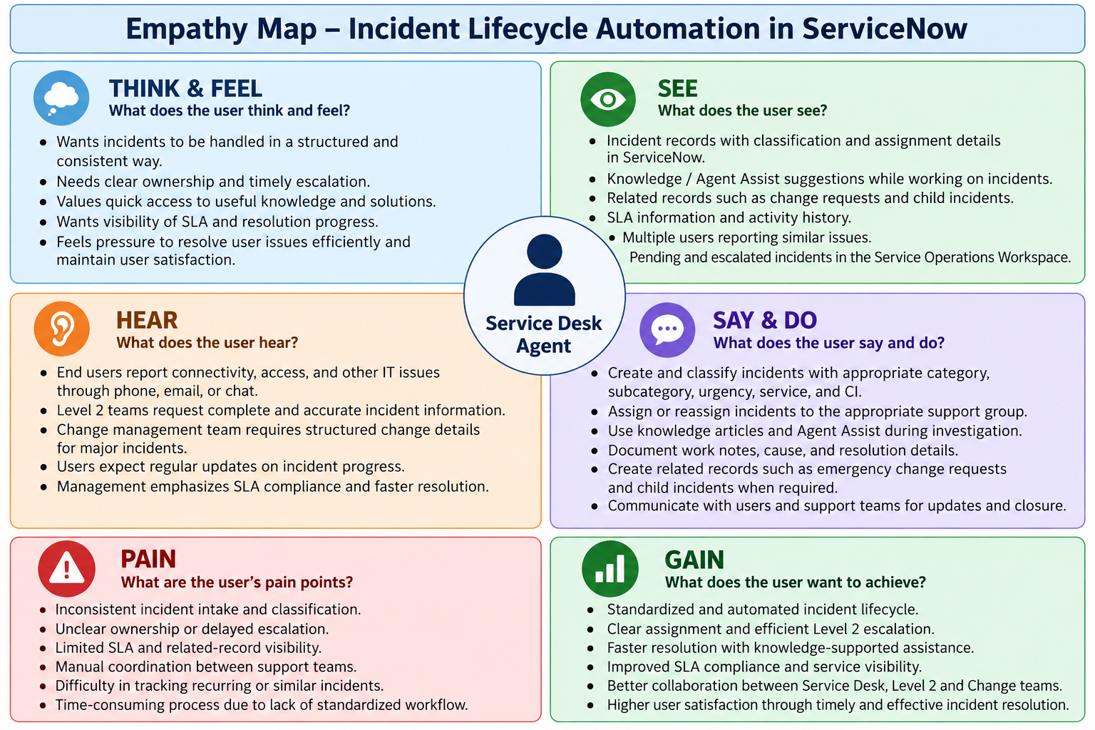
Figure 1: Empathy Map – Service Desk Agent.

2.3 Brainstorming
The project brainstorming is based on the defined project goals: standardize incident intake, capture classification details, use Knowledge and Agent Assist, assign and escalate to Level 2, connect emergency changes, create child incidents, document cause and resolution, create Knowledge articles, and validate SLA and related records.
Idea | Project application
Standardized intake | Incident creation through Service Operations Workspace.
Consistent classification | Category, subcategory, urgency, service, offering and CI.
Knowledge support | Agent Assist and Knowledge article attachment.
Clear escalation | Assignment/reassignment to appropriate support groups and Level 2.
Related work | Emergency change and child incident handling.
Resolution reuse | Cause/resolution documentation and Knowledge article creation.
Traceability | SLA and Related Records validation.

3. REQUIREMENT ANALYSIS

3.1 Customer Journey map
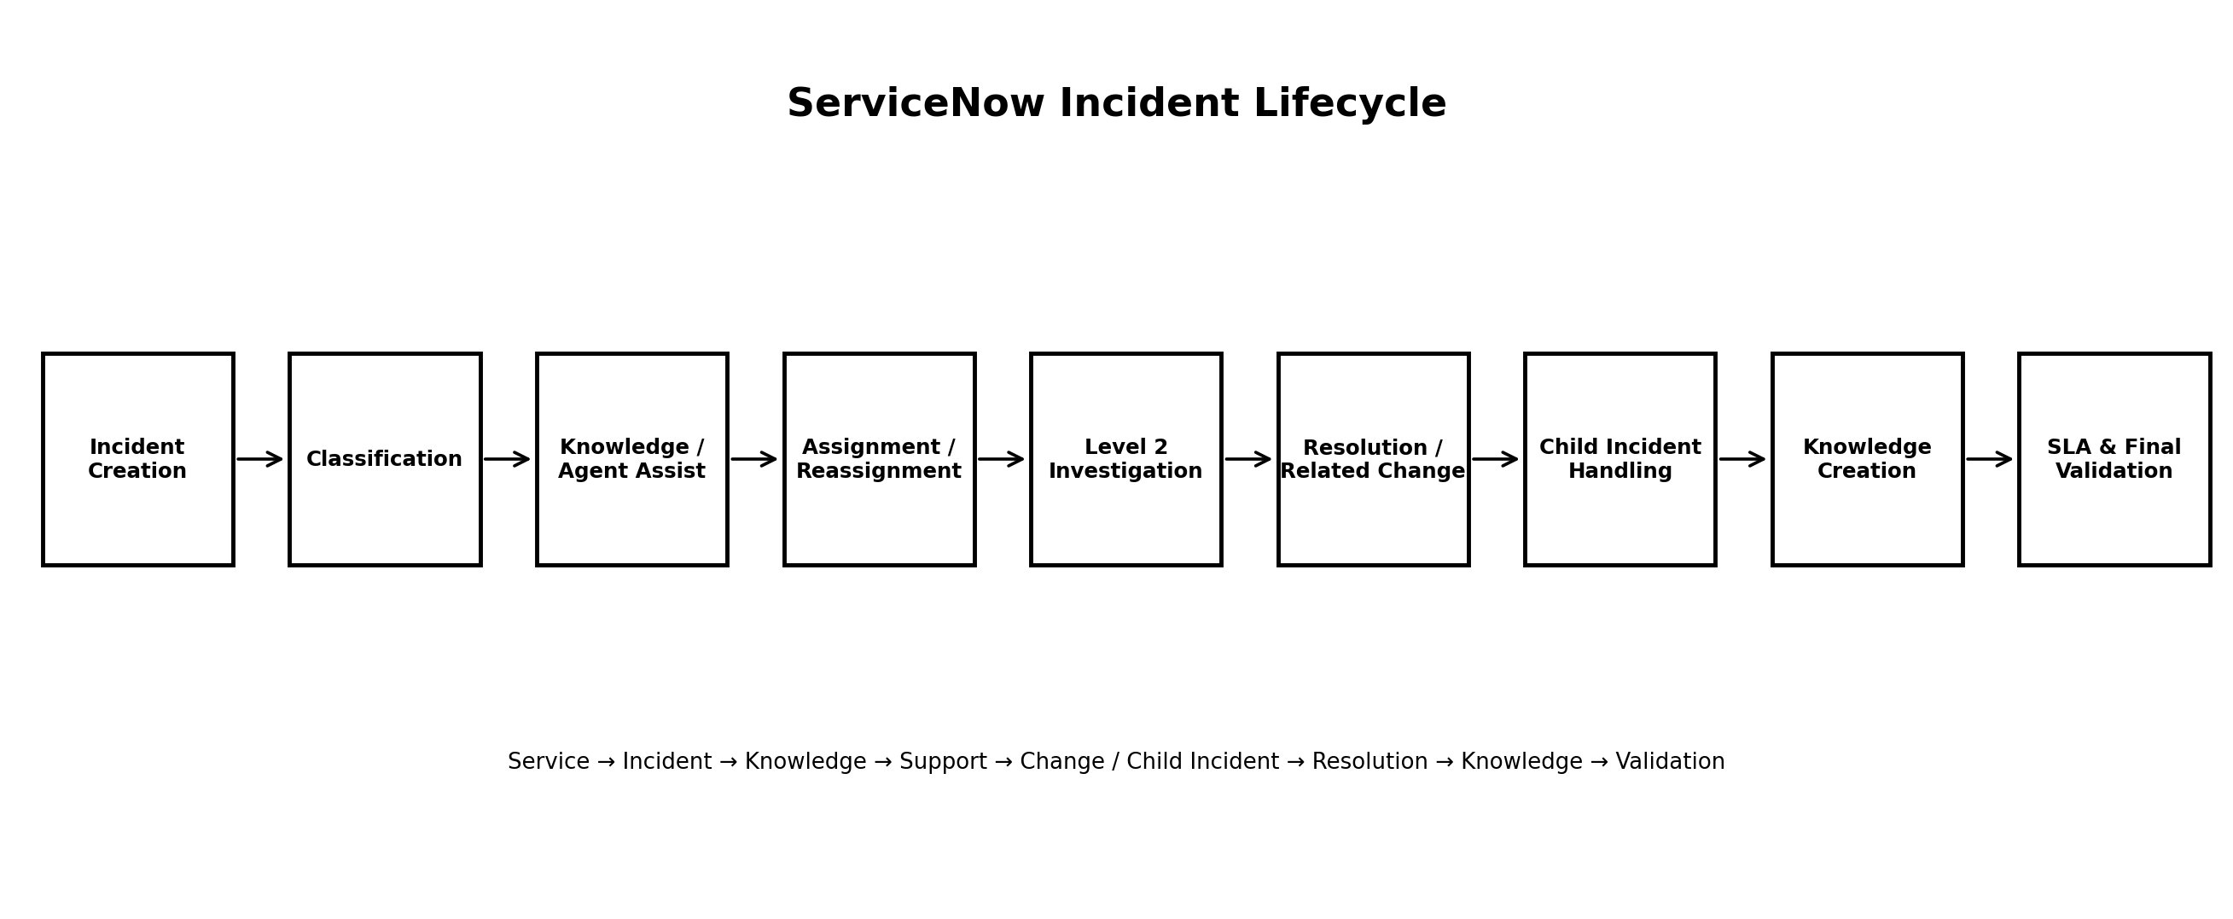
Figure 2: Customer Journey / Incident Lifecycle Workflow.
Stage | Activity | Outcome
Entice | IT issue is reported | Issue enters support process.
Enter | Incident is created | Incident becomes formally trackable.
Engage | Classification, Knowledge, assignment and investigation | Incident is owned and worked by the appropriate team.
Exit | Resolution and related change/child handling | Incident is resolved and documented.
Extend | Knowledge creation and validation | Solution is reusable and lifecycle is traceable.

3.2 Solution Requirement
FR | Requirement | Description
FR-1 | Incident Record Creation | Create incident with caller and short description.
FR-2 | Incident Classification | Capture category, subcategory, urgency, service, service offering and CI.
FR-3 | Knowledge & Agent Assist | Find and attach relevant Knowledge.
FR-4 | Assignment & Escalation | Assign/reassign incidents to support groups and Level 2.
FR-5 | Level 2 Investigation | Provide details, Knowledge, activity and Task SLA visibility.
FR-6 | Change & Child Incidents | Support emergency change activity and child incident creation.
FR-7 | Resolution & Knowledge | Record cause/resolution and create Knowledge article.
FR-8 | SLA & Validation | Verify Task SLAs and Related Records.

3.3 Data Flow Diagram

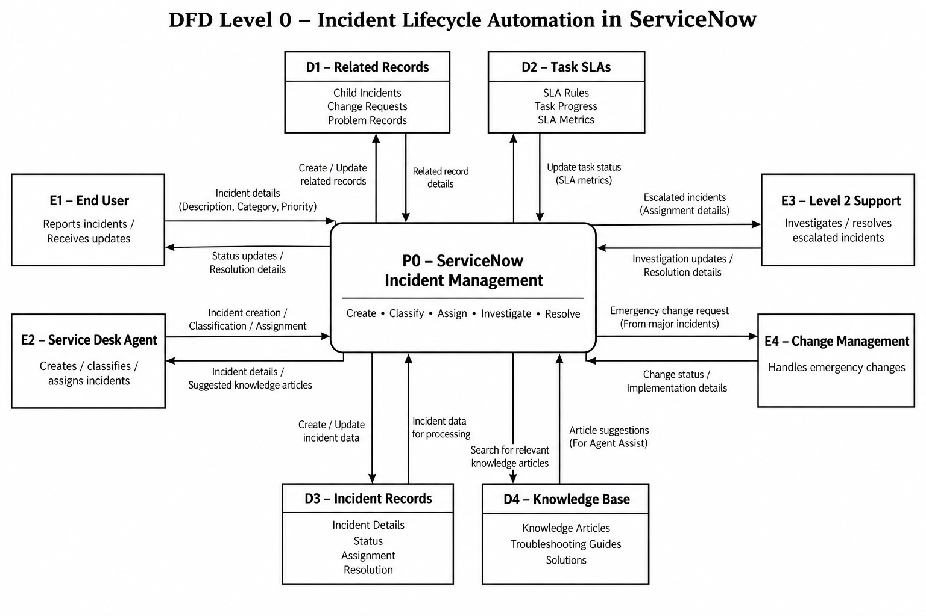
Figure 3: DFD Level 0 – Incident Lifecycle Automation in ServiceNow.

3.4 Technology Stack
Component | Technology / Capability | Purpose
User interface | Service Operations Workspace | Incident creation and operational management.
Core process | ServiceNow Incident Management | Incident lifecycle.
Knowledge | Knowledge Management / Agent Assist | Troubleshooting support.
Change | ServiceNow Change Management | Emergency change activity.
Related records | Child Incidents / Related Records | Related issue tracking.
SLA | Task SLAs | SLA visibility.
Service context | Service / Service Offering / CI | Incident association.
Platform | ServiceNow | Overall solution platform.

4. PROJECT DESIGN

4.1 Problem Solution Fit
Area | Project-specific fit
Customers | End Users, Service Desk Agents, Level 2 Support, Change Management Team, ServiceNow Administrator.
Problems | Inconsistent intake/classification, unclear ownership, delayed escalation, limited SLA visibility, manual coordination and related-record difficulty.
Solution | Structured ServiceNow lifecycle connected to Knowledge, Agent Assist, Change, child incidents and SLA/related records.
Value | Better visibility, standardized ownership, documented resolution and knowledge reuse.

4.2 Proposed Solution
The proposed solution configures the defined Incident Management lifecycle in ServiceNow. It begins with the Remote Access service and Corporate VPN service offering, followed by incident creation and classification. Agents use Knowledge and Agent Assist, assign or reassign incidents, and escalate to Level 2 when required.
For incidents requiring urgent changes, emergency change activity is associated with the incident. Related user issues can be represented through child incidents. After investigation, probable cause and resolution details are recorded, the incident is resolved, and a Knowledge article can be created from the resolved incident. SLA and Related Records are then validated.

4.3 Solution Architecture

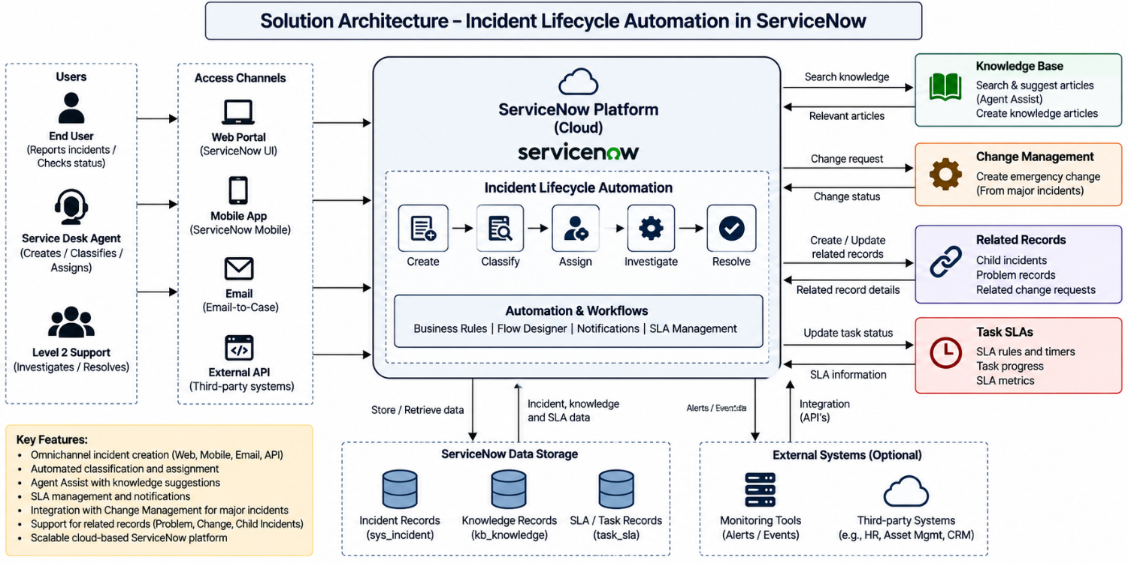
Figure 4: Solution Architecture – Incident Lifecycle Automation in ServiceNow.

5. PROJECT PLANNING & SCHEDULING

5.1 Project Planning
The maintained planning baseline uses 12 user stories across four sprints, with 51 total story points and a planned average velocity of 12.75 story points per sprint.
USN | Planned work |  | Points
USN-1 | Service and Service Offering Setup |  | 5
USN-2 | Incident Record Creation |  | 5
USN-3 | Incident Classification & Prioritization |  | 3
USN-4 | Knowledge Integration & Agent Assist |  | 5
USN-5 | Incident Assignment & Reassignment |  | 5
USN-6 | Level 2 Incident Investigation |  | 3
USN-7 | Emergency Change Management |  | 5
USN-8 | Child Incident Handling |  | 5
USN-9 | Incident Resolution & Closure |  | 3
USN-10 | Knowledge Article Creation |  | 5
USN-11 | SLA & Related-Record Validation |  | 5
USN-12 | Testing & Deployment Validation |  | 2
Sprint |  | Points
Sprint 1 |  | 13
Sprint 2 |  | 13
Sprint 3 |  | 13
Sprint 4 |  | 12
Total |  | 51
Planned Velocity = 51 ÷ 4 = 12.75 story points per sprint.

6. FUNCTIONAL AND PERFORMANCE TESTING

6.1 Performance Testing
The provided UAT information documents functional and lifecycle validation rather than measured load, throughput or response-time benchmarks. Therefore, this report does not invent numerical performance results.
Test area | Validation | Status
Service / offering | Service hierarchy available for incident association. | Pass
Incident creation | Incident is created and trackable. | Pass
Classification | Required classification and service fields are set. | Pass
Knowledge / Agent Assist | Relevant Knowledge is linked. | Pass
Assignment | Ownership transfers to appropriate group. | Pass
Level 2 | Incident details, Knowledge and Task SLAs are visible. | Pass
Emergency change | Change activity is controlled and traceable. | Pass
Child incident | Child is listed under parent. | Pass
Resolution | Cause/resolution recorded and state becomes Resolved. | Pass
Knowledge creation | Article is created and linked. | Pass
SLA / related records | SLA and linked records are visible. | Pass
End-to-end | Complete lifecycle is traceable. | Pass

7. RESULTS

7.1 Output Screenshots
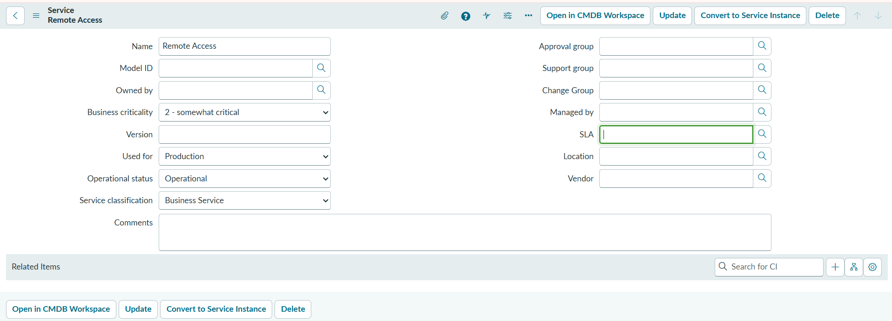

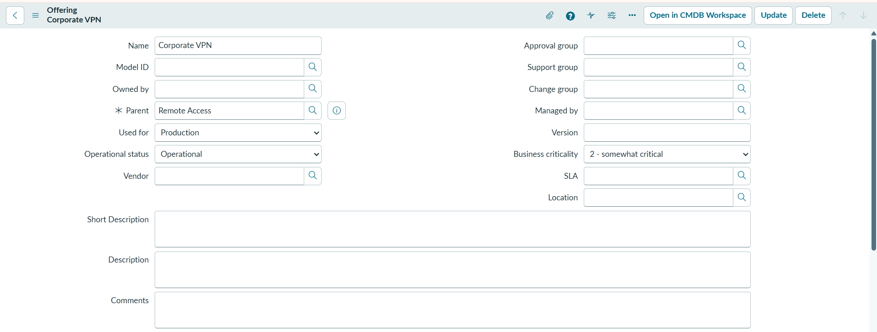

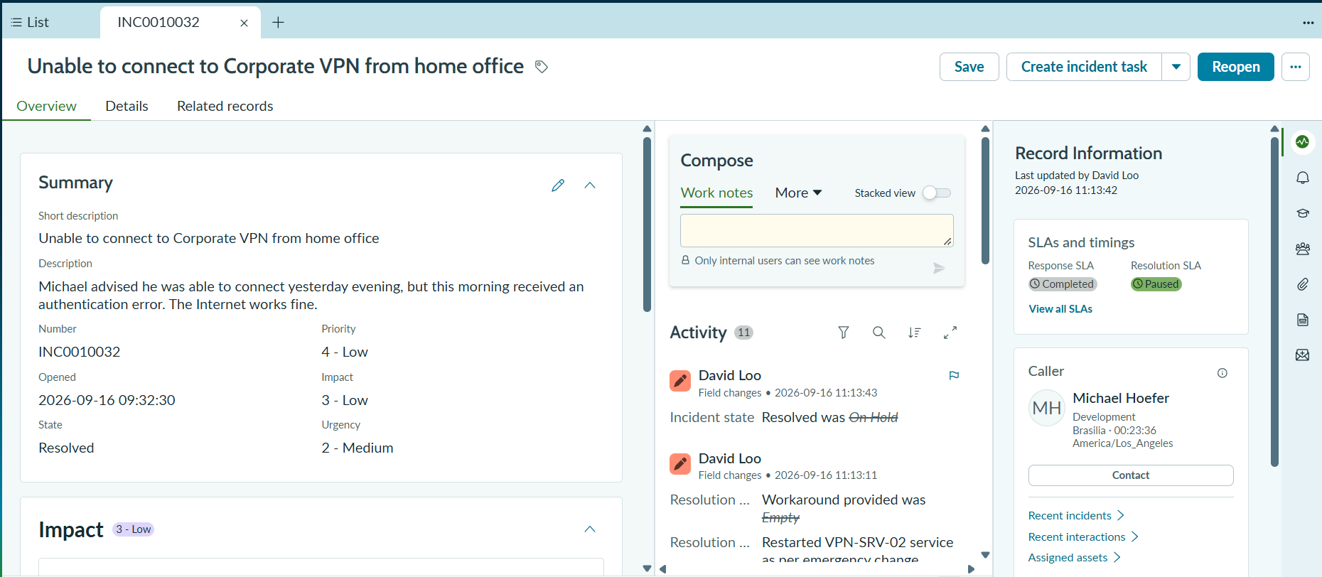

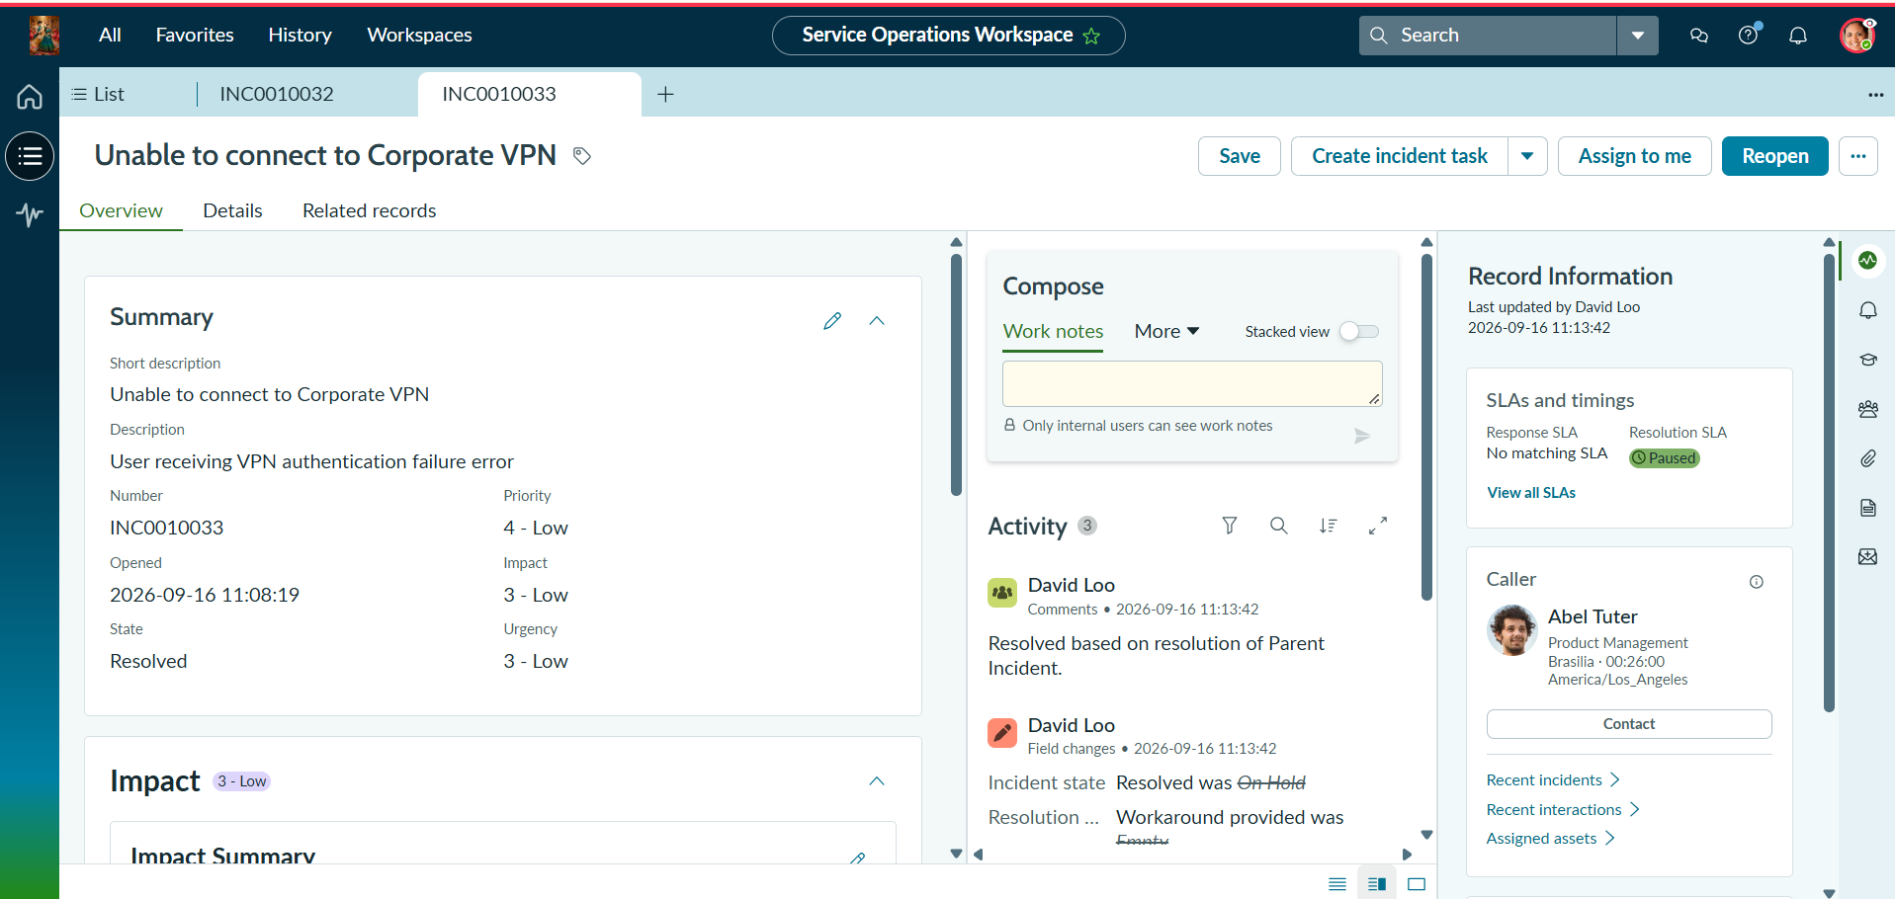

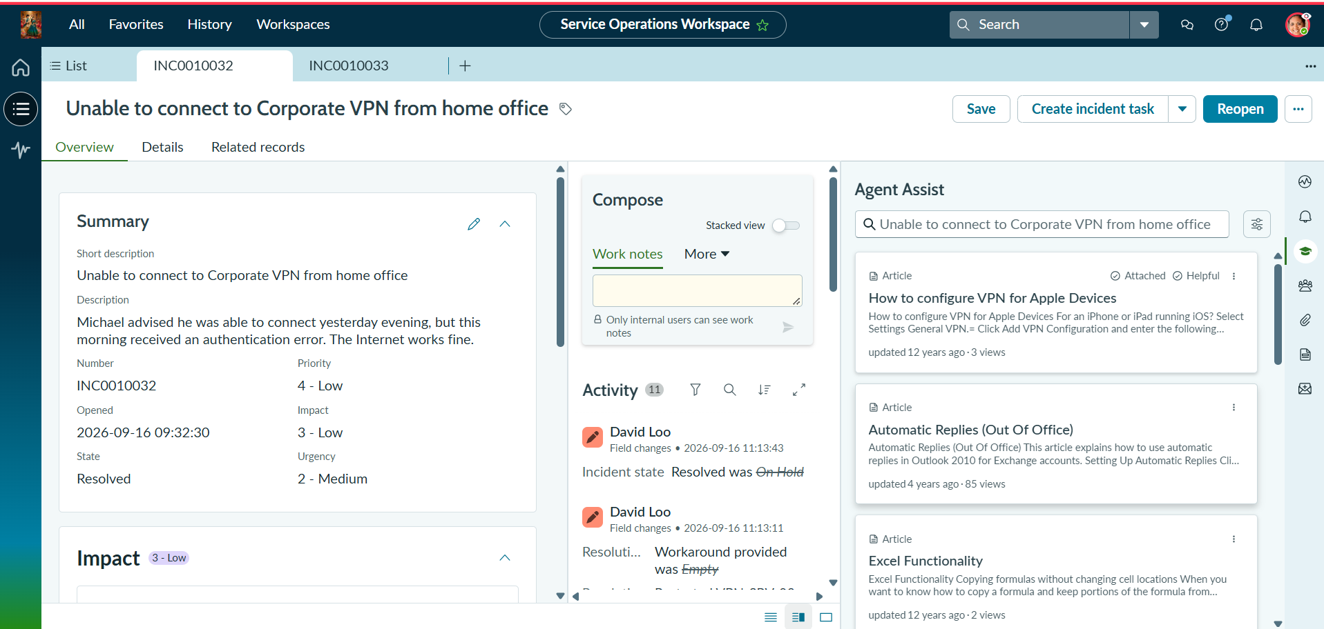

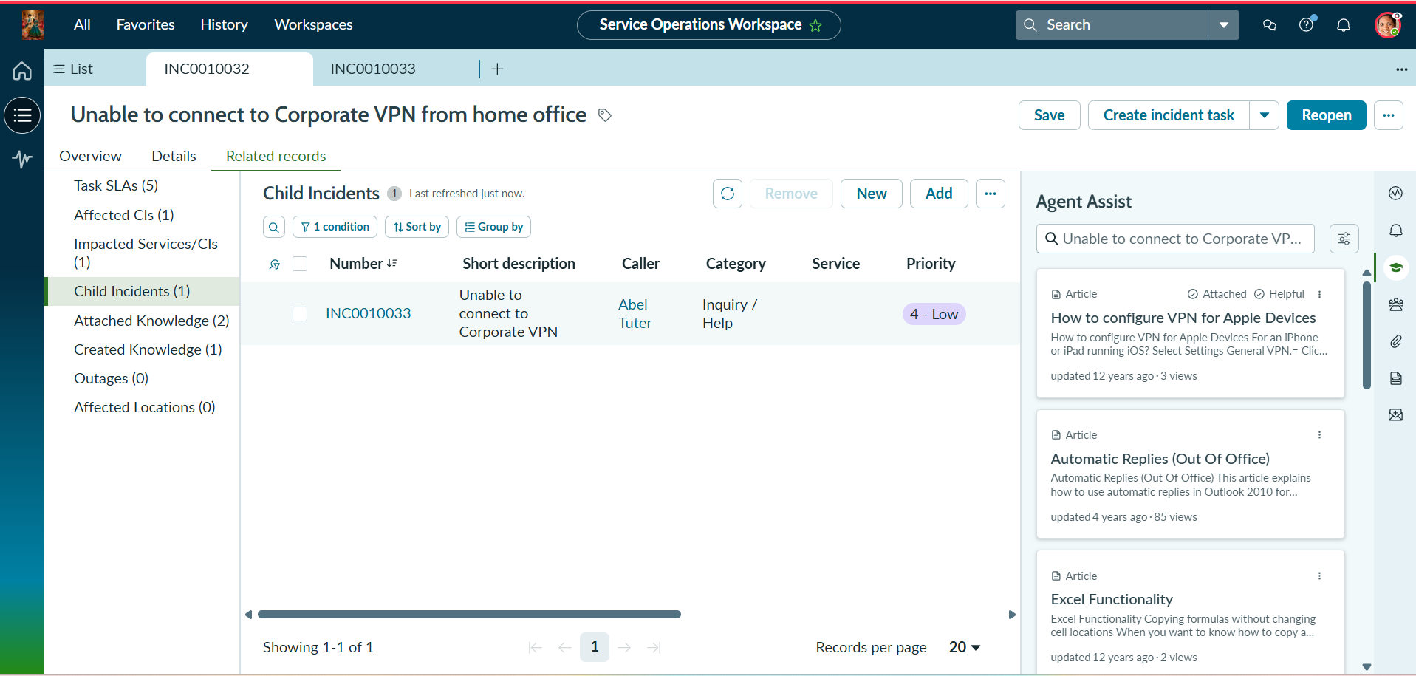

8. ADVANTAGES & DISADVANTAGES
Advantages | Disadvantages / Limitations
Standardized incident creation and classification. | Requires accurate information from users/agents.
Clear ownership and Level 2 escalation. | Requires appropriate ServiceNow configuration and access.
Knowledge-supported troubleshooting. | Knowledge effectiveness depends on maintained content.
Change and child-incident traceability. | Related records require correct user actions.
SLA and activity visibility. | No measured load/performance benchmark was provided.
Documented resolution and Knowledge reuse. | No separate dataset or source-code package was provided.

9. CONCLUSION
Incident Lifecycle Automation in ServiceNow provides a structured approach to Incident Management from initial reporting to final validation. It addresses inconsistent recording and classification, unclear ownership, delayed escalation, limited SLA visibility, manual coordination and difficulty tracking related records.
The lifecycle connects Incident Management with Service Operations Workspace, Knowledge and Agent Assist, Level 2 Support, Change Management, child incidents, resolution documentation, Knowledge creation and SLA/related-record validation. The documented UAT scenarios cover the major functional stages of the lifecycle.

10. FUTURE SCOPE
- Expand the number of services, service offerings, configuration items and support groups.
- Extend the Knowledge base using additional resolved-incident scenarios.
- Add detailed dashboards for incident volume, SLA status, assignment and resolution trends.
- Add further automated notifications and escalation rules within ServiceNow.
- Extend testing with documented negative scenarios and measured performance/load benchmarks.
- Add additional recurring-incident and related-record validation scenarios.

11. APPENDIX

Source Code (if any)
No separate source-code package was provided. The project is documented around ServiceNow configuration and platform capabilities.

Dataset Link
Not applicable. No external dataset was provided or required for this ServiceNow project.

Project Demo Link
https://drive.google.com/file/d/1UBfKiB9ZZsvcLsI6NQ5yIRT9RDCxx1Zn/view?usp=sharing

Project Stakeholders
Stakeholder | Role | Expected impact
End Users | Report IT issues | Faster resolution and transparent tracking.
Service Desk Agents | First-level support | Standardized intake and escalation.
Level 2 Support | Diagnose and resolve | Complete information and clear ownership.
Change Management Team | Handle emergency changes | Structured change control.
ServiceNow Administrator | Maintain configuration | Controlled and trackable process.

Figure 14: Overall Incident Lifecycle Workflow.

